|  |
| --- |
| Circle Language Spec: Commands |

## Public Inactive Clause = Command Out Parameter in a Diagram

The article *Public Inactive Clause = Command Out Parameter* conceptually explained the idea of public inactive clauses. The current article further demonstrates the idea using diagrams.

Active clauses, command calls and active command references in parent commands are always private, because you can not reference a sub-command (see the article *Sub-Commands Are Never Referenced*).

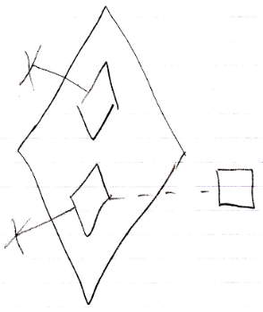

But *inactive* clauses *can* be referenced might be made public.

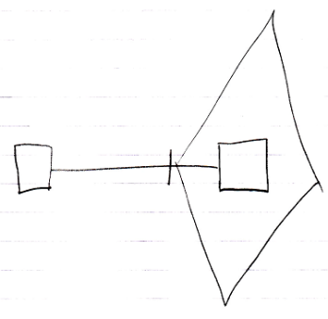

If you make an inactive clause public, you will make it an Object Out parameter: an object produced by the command.